Internet culture is a whole world in itself, constantly evolving alongside the ever-changing online landscape. It's a space where people connect and share ideas through online communities, gaming platforms, and social media. These online spaces foster unique communication styles with their own languages, like abbreviations (LOL, BRB) and emojis, and even inside jokes or memes that spread virally.

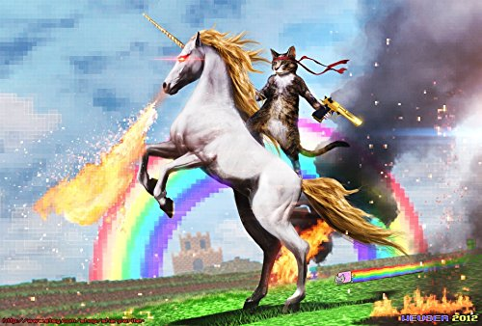

This digital culture thrives on creativity and humor. Trends like challenges and dances on platforms like TikTok, or funny webcomics, all contribute to the ever-growing tapestry of internet culture. It's a place where people can express themselves freely and find communities of like-minded individuals.

However, internet culture isn't without its downsides. Issues like privacy concerns and online harassment can also be part of the picture. But despite these challenges, internet culture remains a powerful force, shaping how we communicate, entertain ourselves, and connect with each other on a global scale.